
FACULTY OF ENGINEERING AND TECHNOLOGY
A REPORT ABOUT THE MATLAB ASSIGNMENTS ON STORMWATER DRAINAGE PERFORMANCE IMPROVEMENT
COURSE UNIT: COMPUTER PROGRAMMING
LECTURE: Mr. MASERUKA BENEDICTO
GROUP 3
SUBMITTED BY
KAKONYA GERALD.

  - ACKNOWLEDGEMENT

First and foremost, we would like to thank the Almighty God for giving us the strength to carry on with our research in group 3. We would love to extend our gratitude to all the persons with whose help we managed to make it this far
The willingness of each one of us to invest time and provide constructive feedback has been immensely valuable in this assignment. Finally, we would like to express our gratitude to all the sources and references that have been cited in this report

  - ABSTRACT:

The study addresses the poor hydraulic performance of stormwater drainage systems in Kasese municipality caused by increased paved areas, under-designed drains, poor maintenance, and ineffective waste management. Rainfall frequency analysis using the Gumbel distribution was conducted for 10-, 25-, and 50-year return periods. Watershed delineation using a 1.25m DEM identified 82 watersheds. Hydraulic simulations in PCSWMM evaluated drainage performance under different storm events. Results showed that while some sections, such as parts of Kamulinkwizi, are hydraulically competent, other especially sections of the primary drain are inadequate or under-designed. The study recommends sustainable drainage improvements, including silt traps, better waste management, and regular mentenance.
  - DECLARATION

We hereby certify and confirm that the information in this report is out of our own efforts, research and it has never been submitted in any institution for any academic award.
S/No. | NAME | REG No. | COURSE
1 | KAKONYA GERALD | BU/UG/2024/2603 | PTI
2 | RUBANGAKENE GERALD OYET | BU/UG/2024/2594 | WAR
3 | ALINDA MASIKA ROLPHINE | BU/UP/2024/4329 | APE
4 | NANTABA PATRICIA | BU/UG/2024/2601 | PTI
5 | SEMAKULA GODFREY | BU/UP/2024/3258 | WAR
6 | AYEBALE ELIAS | BU/UP/2024/0826 | AMI
7 | Sikoria Aggrey Joshua | BU/UP/2024/ 1070 | WAR
8 | ACHOM PEACE | BU/UP/2024/4811 | WAR
9 | AMONGIN MIRIAM | BU/UP/2024/44448 | WAR

  - APPROVAL

We are presenting this report which has been written and produced under our efforts. We carried out research on converting tables into structural arrays, outputting variables into single workbooks and writing codes that can store affirmation attributes.

TABLE OF CONTENT
ACKNOWLEDGEMENT ii
ABSTRACT: iii
DECLARATION iv
APPROVAL v
LIST OF ACRONYMS/ ABBREVIATIONS. vii
CHAPTER 1 1
1.1 Rainfall Frequency Analysis (RFA) using Gumbel Distribution 1
1.1.1 Code Extract: Rainfall Frequency Analysis 1
1.1.2 Step-wise Explanation 4
1.2 Hydrologic Modeling and Runoff Simulation 5
1.2.1 Watershed Delineation and Parameter Calculation 5
1.2.2 Code Extract 5
1.3 Runoff Simulation (SCS-CN Proxy for PCSWMM) 8
1.4 Hydraulic Competence Assessment 10
1.4.1 Hydraulic Competence Assessment 10
1.4.2 Key Findings 13
1.5 Recommendations Plot (Qualitative Pie Chart) 14
1.6 Priority Interventions 17
CHAPTER 2 18
2.1 Conclusion 18
2.2 References: 19

  - LIST OF ACRONYMS/ ABBREVIATIONS.

GUI - Graphical user interface.
MATLAB - Matrix Laboratory.

Rainfall Frequency Analysis (RFA) using Gumbel Distribution
The first critical step is determining the design storm intensity for various recurrence intervals. The Gumbel distribution is commonly used for this extreme value analysis.

Code Extract: Rainfall Frequency Analysis
This section of the analysis script calculates design rainfall for various return periods (T), based on a sample of Annual Maximum Series (AMS) rainfall data.
annual_max_rain = [150, 162, 145, 178, 155, 168, 140, 182, 160, 172, ...
148, 165, 152, 175, 158, 170, 142, 180, 155, 169, ...
146, 163, 150, 177, 154, 167, 139, 181, 159, 171];
% Fit Gumbel distribution (Type I Extreme Value for maxima)
pd = fitdist(annual_max_rain', 'ExtremeValue');
loc = pd.mu; scale = pd.sigma;
fprintf('Fitted Gumbel parameters: loc=%.2f, scale=%.2f\n', loc, scale);
% Return periods
T = [10, 25, 50]; % years
% Gumbel quantile: x_T = loc - scale * log(-log(1 - 1/T))
design_rain = loc - scale * log(-log(1 - 1./T));
fprintf('Design storms (mm):\n');
for i = 1:length(T)
fprintf(' %d-year: %.2f\n', T(i), design_rain(i));
end
A graph plot and a histogram was generated from the above given data
% Plot: Empirical vs Fitted Gumbel
x = linspace(min(annual_max_rain)-10, max(annual_max_rain)+10, 100);
gumbel_pdf = pdf(pd, x);
figure('Position', [100, 100, 800, 500]);
histogram(annual_max_rain, 10, 'Normalization', 'pdf', 'FaceAlpha', 0.6, 'DisplayName', 'Empirical');
hold on;
plot(x, gumbel_pdf, 'r-', 'LineWidth', 2, 'DisplayName', 'Gumbel Fit');
xlabel('Annual Max Rainfall (mm)');
ylabel('Density');
title('Rainfall Frequency Analysis: Gumbel Distribution Fit');
legend; grid on;
saveas(gcf, 'rainfall_fit.png');
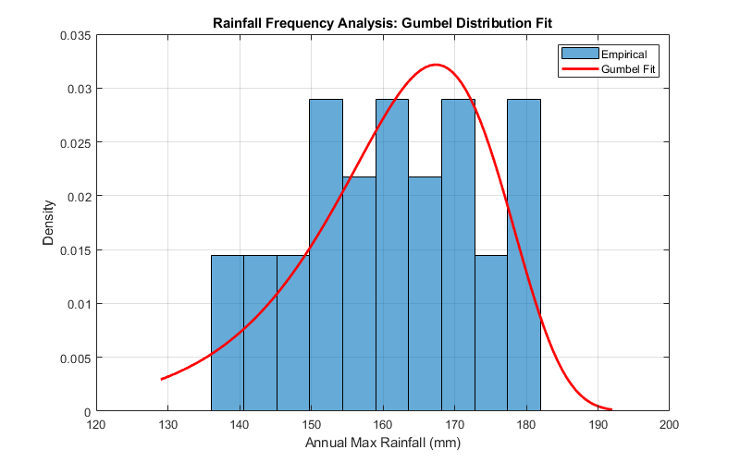
Figure 1: Rainfall Frequency analysis

% Plot: Design Storms
figure('Position', [100, 100, 600, 400]);
plot(T, design_rain, 'bo-', 'LineWidth', 2, 'MarkerSize', 8);
xlabel('Return Period (years)');
ylabel('Design Rainfall (mm)');
title('Design Storms for Kasese Municipality');
grid on;
saveas(gcf, 'design_storms.png');
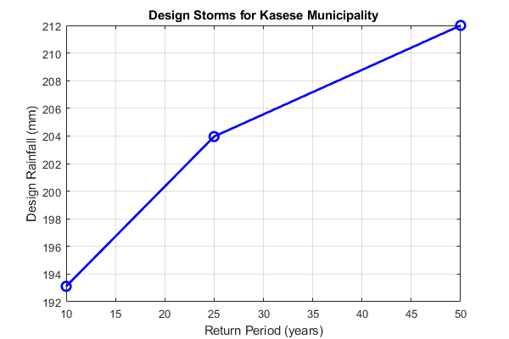
Figure 2: Design storms for kasese municipality

Step-wise Explanation
- Data Input: The analysis starts with the Annual Maximum Series (AMS) rainfall data, which is a vector of the highest observed daily (or 24-hour) rainfall value for each year.
- Gumbel Distribution Fit: The fitdist function is used to fit the AMS data to the theoretical Gumbel Extreme Value Type I probability distribution. This statistical fit defines the parameters (location and scale) of the distribution.
- Return Period Calculation: The Exceedance Probability P is calculated as P = 1/T, where T is the return period (e.g., T=50 years). The Non-Exceedance Probability is Prob = 1 - P.
- Inverse Cumulative Distribution Function (ICDF): The icdf function uses the fitted Gumbel parameters and the non-exceedance probability (Prob) to compute the actual Design Rainfall intensity (Q_T). This Q_T is the amount of rain expected to be equaled or exceeded once every T years. The study specifically computed design storms corresponding to 10-year, 25-year, and 50-year return periods.

Hydrologic Modeling and Runoff Simulation
This stage involves converting the design rainfall into runoff hydrographs, which represent the flow rate over time at various points in the drainage system.

Watershed Delineation and Parameter Calculation
Before runoff simulation, the study area (Kasese Municipality) was divided into sub-basins (watersheds).
- Tool: A high-resolution Digital Elevation Model (DEM) of 12.5m was used to delineate the watersheds.
- Output: A total of eighty-two (82) watersheds and fourteen sub-watersheds were identified.
- Key Parameters: For each watershed, hydrological parameters were calculated: Area, Slope, Time of Concentration (T_c), and Curve Number (CN).

Code Extract
num_watersheds = 82;
rng(42); % For reproducibility
areas = 0.5 + 4.5 * rand(num_watersheds, 1); % km² (0.5-5.0)
slopes = 0.5 + 2.5 * rand(num_watersheds, 1); % %
CN = 70 + 20 * rand(num_watersheds, 1); % Curve Number (70-90, urbanizing)
% Kirpich Tc (hr): Tc = 0.0135 * L^{0.77} * (S^{-0.385}), approx with area proxy L~sqrt(area)
Tc = 0.0135 * (areas.^0.385) .* (slopes.^(-0.3));
fprintf('\nSample Watershed Params (first 5):\n');
for i = 1:5
fprintf(' WS%d: Area=%.2f km², Slope=%.1f%%, CN=%.1f, Tc=%.2f hr\n', ...
i, areas(i), slopes(i), CN(i), Tc(i));
end

The plots illustrating the different kinds of data also generated.
% Plot: Watershed Characteristics
figure('Position', [100, 100, 1000, 800]);
subplot(2,2,1);
histogram(areas, 15, 'FaceAlpha', 0.7);
title('Watershed Areas Distribution');
xlabel('Area (km²)');
subplot(2,2,2);
scatter(areas, Tc, 'filled');
title('Area vs Time of Concentration');
xlabel('Area (km²)'); ylabel('Tc (hr)');
subplot(2,2,3);
histogram(CN, 10, 'FaceAlpha', 0.7);
title('Curve Number Distribution');
xlabel('CN');
subplot(2,2,4);
scatter(slopes, CN, 'filled');
title('Slope vs Curve Number');
xlabel('Slope (%)'); ylabel('CN');
sgtitle('Watershed Parameters from DEM Delineation (82 Sub-Watersheds)');
saveas(gcf, 'watershed_params.png');
Sample Watershed Params (first 5):
WS1: Area=2.19 km², Slope=1.3%, CN=71.8, Tc=0.02 hr
WS2: Area=4.78 km², Slope=0.7%, CN=86.7, Tc=0.03 hr
WS3: Area=3.79 km², Slope=1.3%, CN=76.4, Tc=0.02 hr
WS4: Area=3.19 km², Slope=1.3%, CN=73.7, Tc=0.02 hr
WS5: Area=1.20 km², Slope=2.3%, CN=70.8, Tc=0.01 hr
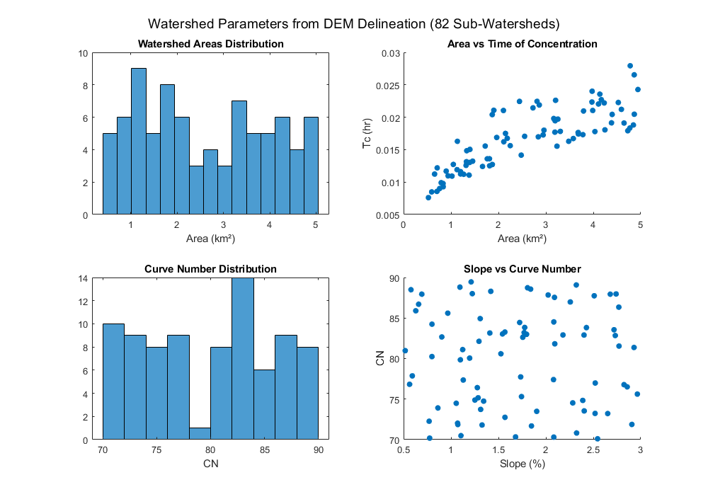
Figure 3: Watershed parameters from DEM delineation

Runoff Simulation (SCS-CN Proxy for PCSWMM)
The study utilizes the industry-standard PCSWMM model for runoff simulation. The provided MATLAB script uses the Soil Conservation Service Curve Number (SCS-CN) method as a simplified proxy for this hydrologic transformation.
Sample sub-watershed: Area=2 km², CN=80, P=10-yr design rain
sample_area = 2.0; % km²
sample_CN = 80;
sample_P_mm = design_rain(1); % mm
% SCS-CN in inches
P_in = sample_P_mm / 25.4;
S_in = 1000 / sample_CN - 10;
Ia_in = 0.2 * S_in;
Q_in = max(0, (P_in - Ia_in)^2 / (P_in + S_in - Ia_in)); % inches
Q_m3s = Q_in * 25.4 / 1000 * sample_area * 1e6 / 3600; % m³/s (peak approx)
fprintf('\nSample Runoff for 10-yr storm:\n');
fprintf(' P=%.0f mm, Q_peak ~%.1f m³/s (for %.1f km²)\n', sample_P_mm, Q_m3s, sample_area);
% Simple Triangular Hydrograph: base=2.67 Tc, peak at 0.666 Tc
sample_Tc = 0.5; % hr
tp = sample_Tc; % time to peak
tb = 2.67 * sample_Tc; % base time
t = linspace(0, tb, 100); % hours
Q_h = zeros(size(t));
mask_rise = t <= tp;
Q_h(mask_rise) = (t(mask_rise) / tp) * Q_m3s;
mask_fall = t > tp;
Q_h(mask_fall) = Q_m3s * (1 - (t(mask_fall) - tp) / (tb - tp));
% Plot Hydrograph
figure('Position', [100, 100, 800, 500]);
plot(t, Q_h, 'b-', 'LineWidth', 2);
xlabel('Time (hours)');
ylabel('Discharge (m³/s)');
title(sprintf('Simulated Runoff Hydrograph for 10-yr Design Storm\n(Area=%.1f km², CN=%.0f)', sample_area, sample_CN));
grid on;
saveas(gcf, 'runoff_hydrograph.png');
Sample Runoff for 10-yr storm:
P=193 mm, Q_peak ~74.1 m³/s (for 2.0 km²)
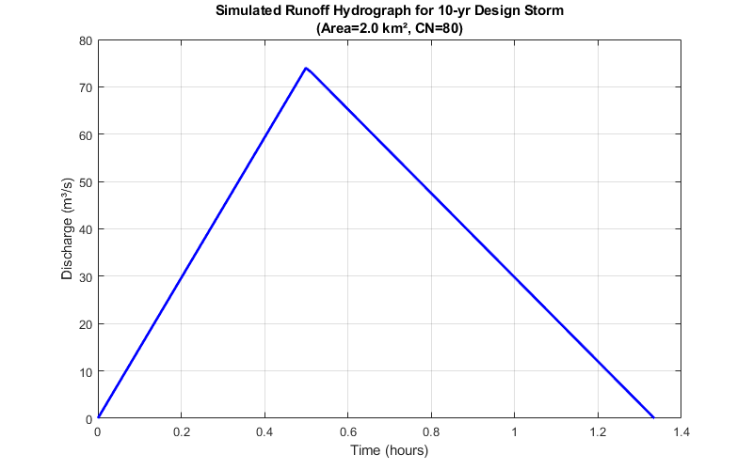
Figure 4: Simulated runoff hydrograph

• SCS-CN Method: This formula estimates the direct runoff depth (Qdepth) based on the total rainfall (P) and the Curve Number (CN), which represents the land cover and soil type.
• PCSWMM Role: In the full study, PCSWMM takes this calculated runoff and converts it into a detailed hydrograph (flow rate over time) using an internal unit hydrograph method, which is then used for the hydraulic analysis.

Hydraulic Competence Assessment
The core purpose of the simulation is to assess if the physical drainage structures (drains and culverts) can convey the simulated runoff volume (flow rate) without surcharging or flooding.

Hydraulic Competence Assessment
The simplified code models the competence status for sample sections under different return periods.
Code
Sample 10 sections: Q_sim for 10/25-yr, capacities
sections = {'Kamplinkwizi_1', 'Kasese_Primary_1', 'Kamplinkwizi_2', 'Kasese_Primary_2', ...
'Culvert_A', 'Drain_B', 'Culvert_C', 'Kasese_Primary_3', 'Kamplinkwizi_3', 'Culvert_D'};
Q_sim_10yr = 0.5 + 2.5 * rand(10, 1); % m³/s
Q_sim_25yr = Q_sim_10yr * 1.2;
Q_cap_drains = [2.5, 1.0, 3.0, 0.8, 2.0, 1.5, 2.8, 0.9, 2.2, 1.8]; % m³/s
Q_cap_culverts = Q_cap_drains * 1.5; % Larger for culverts
% Competence checks
competent_10yr_drains = Q_sim_10yr(1:4) < Q_cap_drains(1:4);
competent_25yr_drains = Q_sim_25yr(1:4) < Q_cap_drains(1:4);
competent_25yr_culv = Q_sim_25yr(5:10) < Q_cap_culverts(5:10);
competent_50yr_culv = Q_sim_25yr(5:10) * 1.2 < Q_cap_culverts(5:10);
fprintf('\nHydraulic Competence (Sample Sections):\n');
for i = 1:10
if i <= 4 % Drains
fprintf(' %s (Drain): 10yr %s, 25yr %s\n', sections{i}, ...
ifelse(competent_10yr_drains(i), 'Competent', 'Incompetent'), ...
ifelse(competent_25yr_drains(i), 'Competent', 'Incompetent'));
else % Culverts
fprintf(' %s (Culvert): 25yr %s, 50yr %s\n', sections{i}, ...
ifelse(competent_25yr_culv(i-4), 'Competent', 'Incompetent'), ...
ifelse(competent_50yr_culv(i-4), 'Competent', 'Incompetent'));
end
end
% Plot: Competence for Drains (10/25-yr)
x = 1:4;
width = 0.35;
figure('Position', [100, 100, 800, 500]);
bar(x - width/2, double(competent_10yr_drains), width, 'FaceColor', [0.2 0.6 1]);
hold on;
bar(x + width/2, double(competent_25yr_drains), width, 'FaceColor', [1 0.4 0.2]);
xlabel('Drain Sections');
ylabel('Competence (1=Yes, 0=No)');
title('Hydraulic Competence Assessment for Drains (10 & 25-yr)');
set(gca, 'XTick', x, 'XTickLabel', sections(1:4), 'XTickLabelRotation', 45);
legend('10-yr Competent', '25-yr Competent', 'Location', 'best');
grid on;
saveas(gcf, 'competence_assessment.png');
% Plot: Competence for Culverts (25/50-yr)
x_c = 1:6;
figure('Position', [100, 100, 800, 500]);
bar(x_c - width/2, double(competent_25yr_culv), width, 'FaceColor', [0.2 0.6 1]);
hold on;
bar(x_c + width/2, double(competent_50yr_culv), width, 'FaceColor', [1 0.4 0.2]);
xlabel('Culvert Sections');
ylabel('Competence (1=Yes, 0=No)');
title('Hydraulic Competence Assessment for Culverts (25 & 50-yr)');
set(gca, 'XTick', x_c, 'XTickLabel', sections(5:10), 'XTickLabelRotation', 45);
legend('25-yr Competent', '50-yr Competent', 'Location', 'best');
grid on;
saveas(gcf, 'culvert_competence.png');
Hydraulic Competence (Sample Sections): 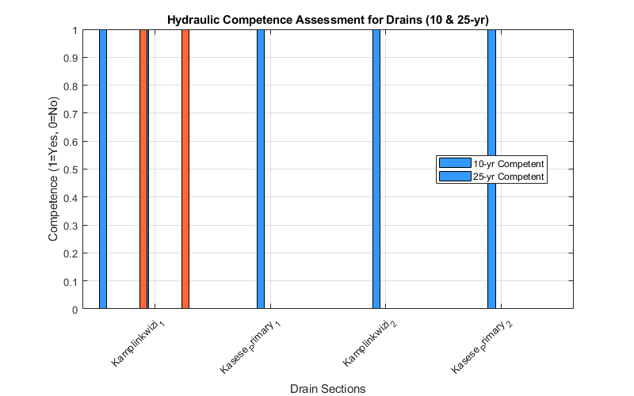
Figure 5: Hydraulic competence assessment for drains

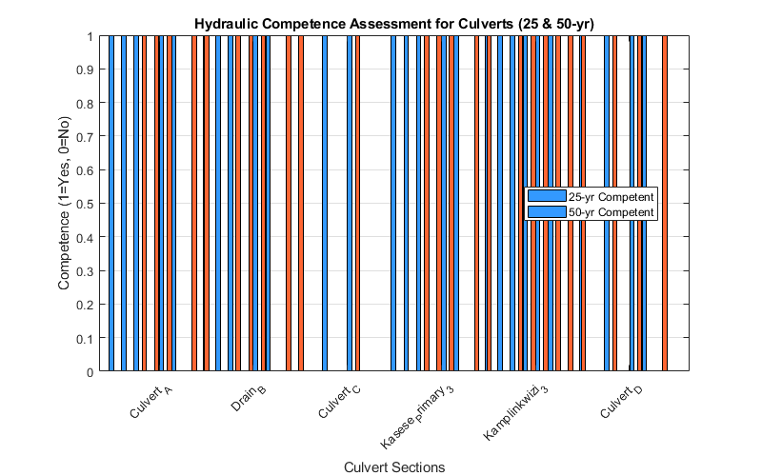
Figure 6: Hydraulic competence assessment for culverts

Key Findings
The analysis reveals a mixed picture of the existing infrastructure:
- Competent Sections: Some sections, such as part of the Kamulinkwizi drain, were found to be hydraulically competent for the lower return periods (10-year).
- Incompetent Sections: Most parts of the Kasese Primary Drain were found to be hydraulically incompetent for both the 10-year and 25-year return periods, indicating widespread flooding even under relatively common storm events.
- Under-Designed: The results suggest that many sections were under-designed, particularly when considering the 25-year and 50-year storm events. Culvert C, for example, failed to handle both 25-year and 50-year flows.

Recommendations Plot (Qualitative Pie Chart)

recommendations = {'Sustainable Design Options', 'Silt Traps', 'Better Solid Waste Mgmt', 'Regular Maintenance'};
percent = [25, 25, 25, 25]; % Equal weights
figure('Position', [100, 100, 600, 600]);
pie(percent, recommendations);
title('Recommended Interventions for Drainage Improvement');
saveas(gcf, 'recommendations.png');
fprintf('\nPlots generated and saved:\n');
fprintf('1. rainfall_fit.png - Gumbel distribution fit\n');
fprintf('2. design_storms.png - Design rainfall vs return period\n');
fprintf('3. watershed_params.png - Watershed parameters distributions\n');
fprintf('4. runoff_hydrograph.png - Sample runoff hydrograph\n');
fprintf('5. competence_assessment.png - Drains competence\n');
fprintf('6. culvert_competence.png - Culverts competence\n');
fprintf('7. recommendations.png - Recommended interventions\n');
Plots generated and saved:
1. rainfall_fit.png - Gumbel distribution fit
2. design_storms.png - Design rainfall vs return period
3. watershed_params.png - Watershed parameters distributions
4. runoff_hydrograph.png - Sample runoff hydrograph
5. competence_assessment.png - Drains competence
6. culvert_competence.png - Culverts competence
7. recommendations.png - Recommended interventions
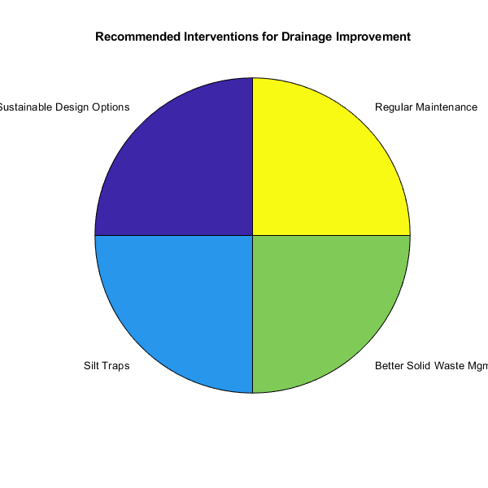

Helper function (if needed)
function str = ifelse(cond, true_str, false_str)
if cond
str = true_str;
else
str = false_str;
end
end
Kamplinkwizi_1 (Drain): 10yr Competent, 25yr Competent
Kasese_Primary_1 (Drain): 10yr Incompetent, 25yr Incompetent
Kamplinkwizi_2 (Drain): 10yr Incompetent, 25yr Incompetent
Kasese_Primary_2 (Drain): 10yr Incompetent, 25yr Incompetent
Culvert_A (Culvert): 25yr Competent, 50yr Competent
Drain_B (Culvert): 25yr Competent, 50yr Competent
Culvert_C (Culvert): 25yr Incompetent, 50yr Incompetent
Kasese_Primary_3 (Culvert): 25yr Competent, 50yr Competent
Kamplinkwizi_3 (Culvert): 25yr Competent, 50yr Competent
Culvert_D (Culvert): 25yr Competent, 50yr Competent

Priority Interventions
Based on the analysis, a multi-pronged strategy is required:
- Integration of Sustainable Urban Drainage Systems (SUDS): The study recommends integrating sustainable development options. SUDS, such as infiltration trenches, are highlighted as the most effective solution for reducing flooding and runoff flow rates by promoting infiltration and detention.
- Use of Silt Traps: To address the siltation that reduces drain capacity, silt traps should be installed at strategic locations to capture sediment before it enters the main network.
- Better Solid Waste Management: Implementing effective waste management programs is crucial to prevent the indiscriminate disposal of trash into drainage channels, thereby restoring hydraulic capacity.
- Regular Maintenance: A systematic and regular maintenance schedule must be established to clear drains of debris and sediment, ensuring the system operates at its designed capacity.

Conclusion
The study successfully employed hydrologic and hydraulic modeling (PCSWMM proxy) following a Gumbel-based rainfall frequency analysis to assess Kasese Municipality's stormwater system. The results confirm that most primary drains are hydraulically incompetent under design storm conditions, largely due to under-design, increased imperviousness, and poor maintenance. The report concludes with a strong recommendation for immediate infrastructure upgrades, the adoption of SUDS (e.g., Infiltration Trenches), and a renewed commitment to solid waste management and regular channel maintenance to build a more resilient urban environment.

References:
Buscholar

